**Original Data:**

Using 20 epochs with a batch size of 32: .5453 accuracy



Using 20 epochs with a batch size of 12: .6997 accuracy



Using 30 epochs batch size 128: .6418 accuracy

**Changing sequence length from 20 to 15:**

Using 128 batch, 15 length, and 3 epochs: .5901

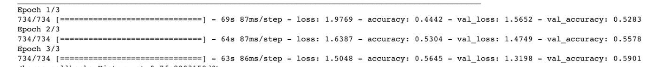

Using 128 batch, 15 length, and 10 epochs: .6410

Using 128 batch, 15 length, and 20 epochs: .6422

Using 128 batch, 15 length, and 30 epochs: .6374

**Using the second dataset with duplicated words deleted (20 sequence length):**

Using 64 batch size and 5 epochs: .5760

Using 128 batch size and 5 epochs: .6058

Using 128 batch, 15 length, and 30 epochs: .6388Okay

